DAY 1:

* Design the player skeleton in paint

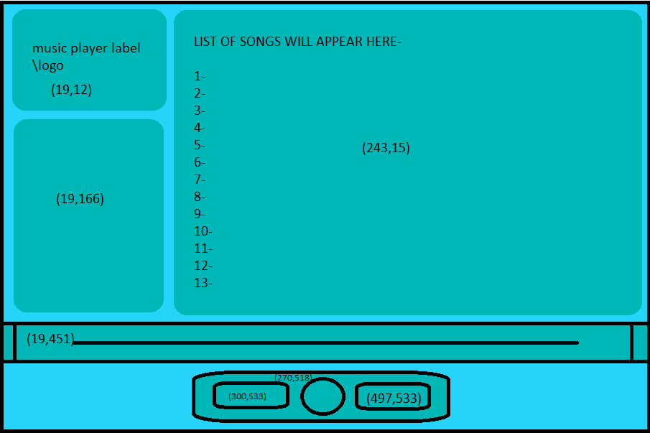

DAY 2:

* Read all documentations related to the requirements for the designing of this product

DAY 3:

* Create the music player by coding it
* Read all the documents as to how to use media i.e. music in tkinter window

DAY 4:

* Implement the media in code